**Data Modelling - PROG1825**

# Assignment #4a

|  |
| --- |
| After successfully completing this assignment, you will be able to:   * Use various types of queries * Create a form * Modify a form |

Create 3 queries:

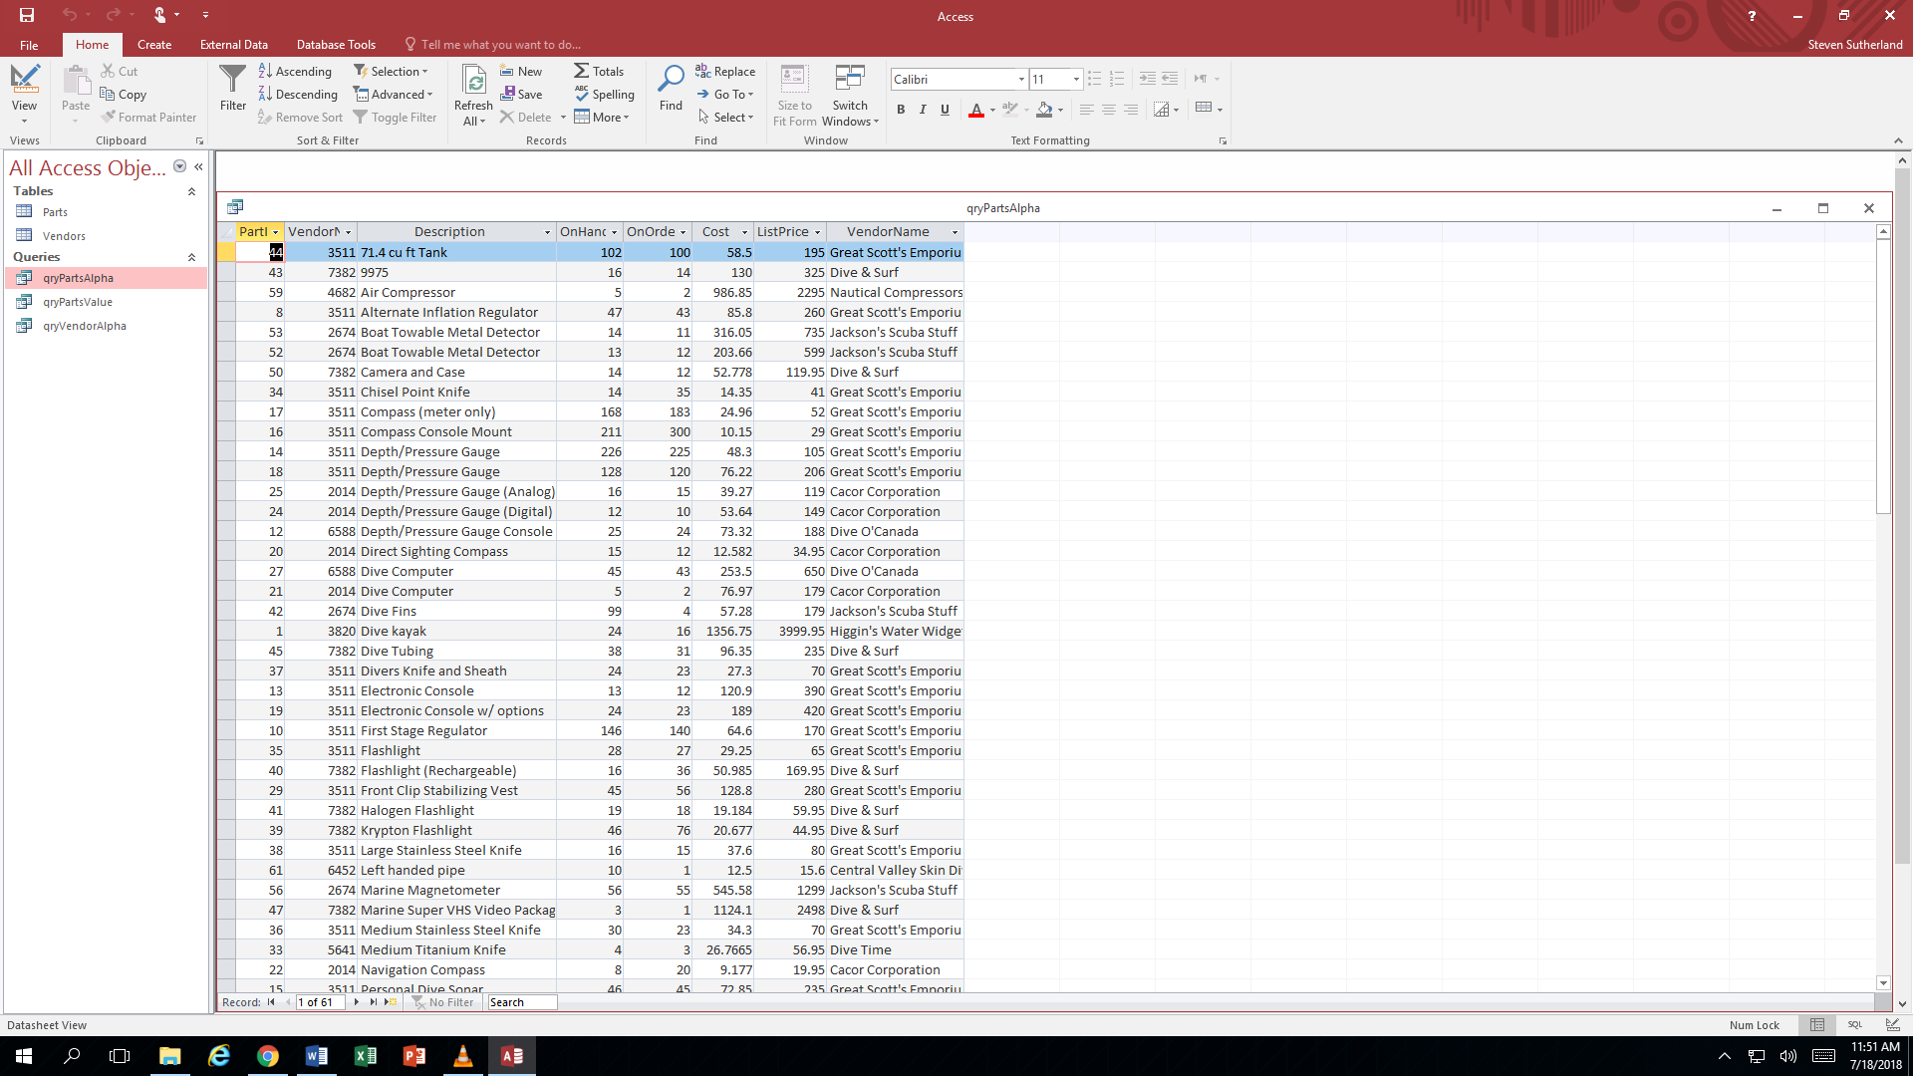

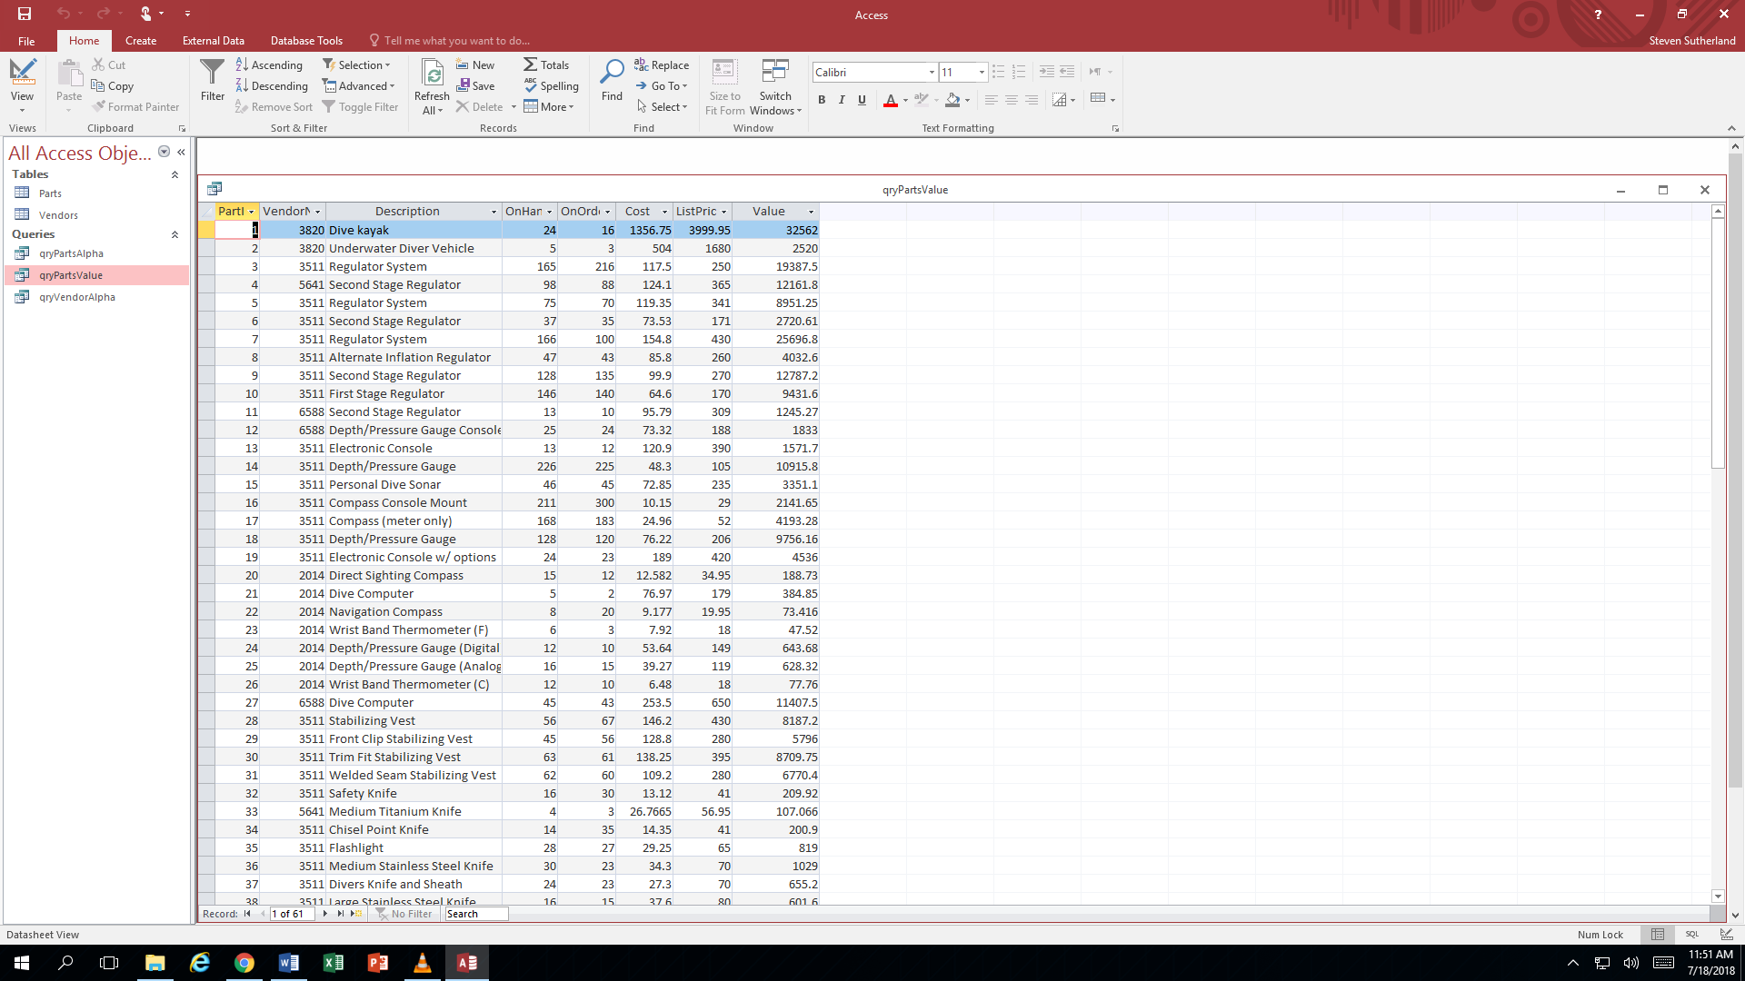

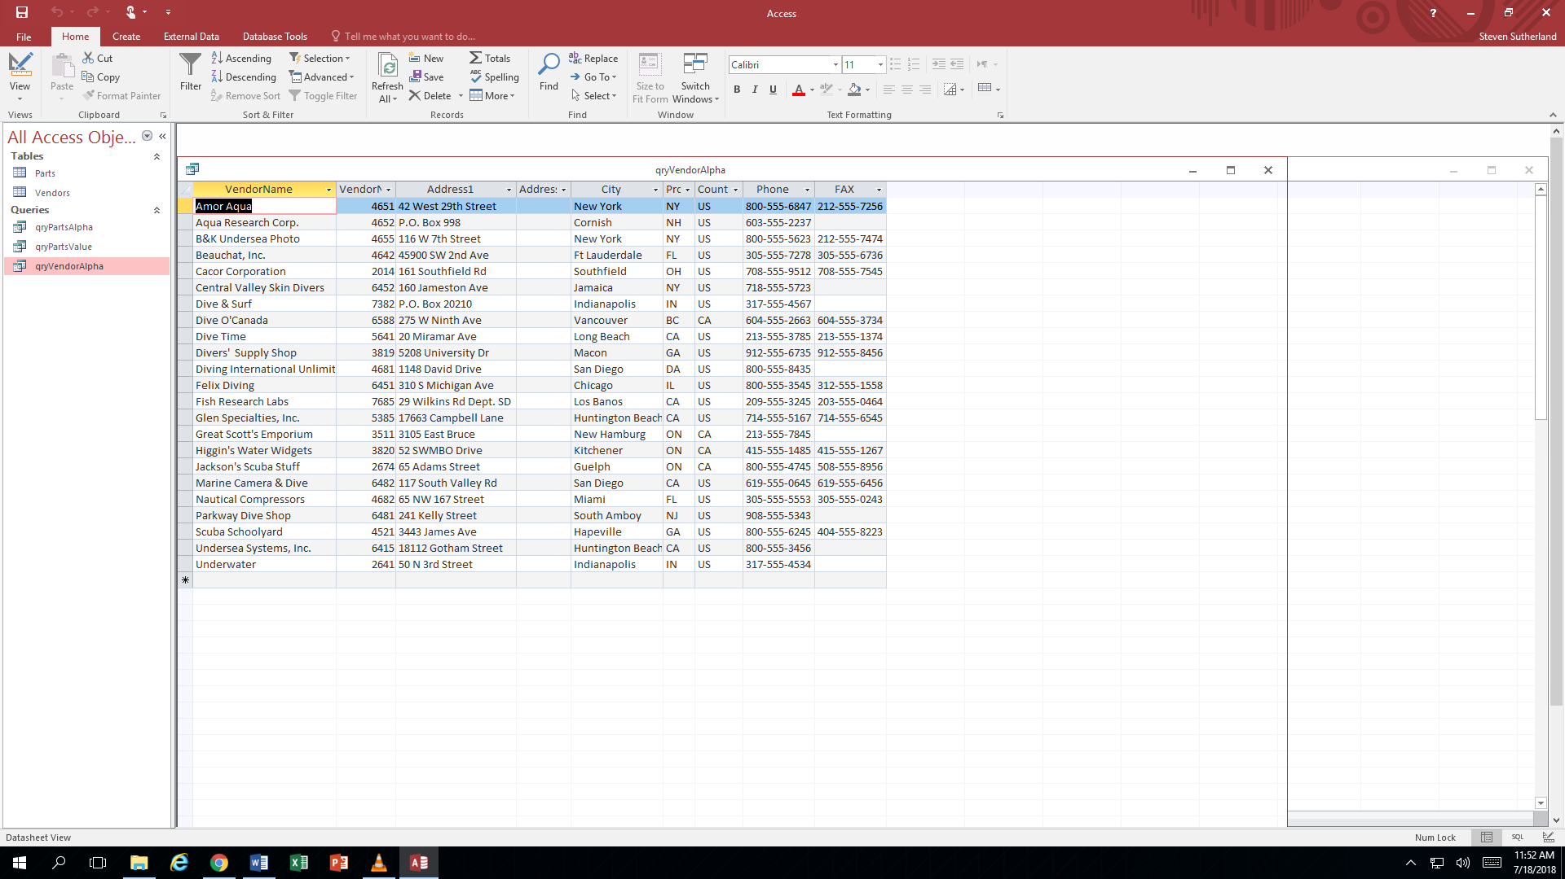

From Query I create:

Append query

Update query

Cross Tab query

**Due end of class - July 18**